1. **Shape of Dataset – 10908 Observations and 54 features**



1. **Different Features**

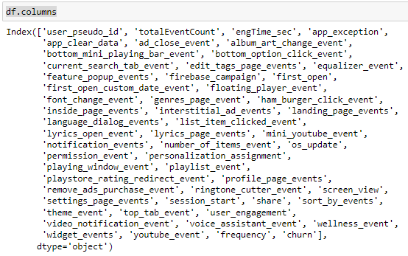

1. **Target Feature is ‘Churn’ Feature**
2. **Each Observation is Unique**

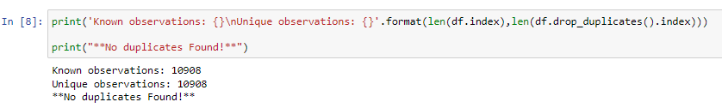

1. **There is not any missing or null values present in the dataset**
2. **Summary of Unique Values by Feature**

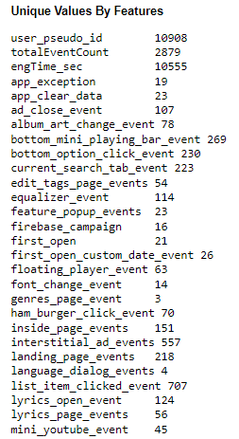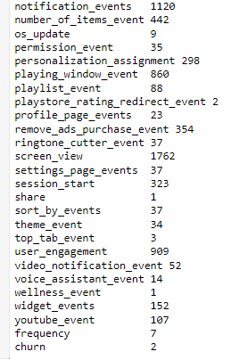

1. **Pie Chart representing Percentage Churned and Percentage Not Churned Observation**

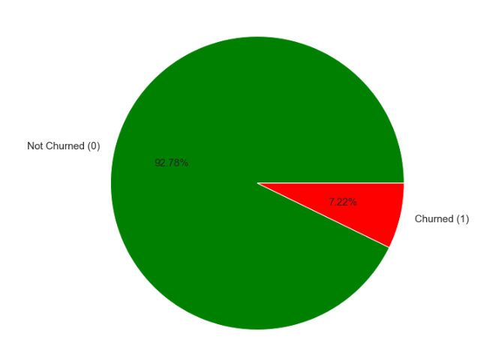

1. **Bivariate Analysis**

* I have performed Bivariate Analysis by taking each feature and compared it with our target feature i.e. Churn Feature.
* I have performed Z test and T test and corresponding observed p value for both the test.
* I have assumed my Null Hypothesis as distribution of both the features are same
* If p-value > 0.05, that means the two samples are more or less similar to each other.
* If p-value < 0.05, then the two samples are significantly different.
* Based on p value i.e. if p value < 0.5, then I conclude that, that feature is more important for our analysis and I figured out 14 important Features out of 53 features with 95% Confidence Interval
* The 14 important different features are



1. **Bivariate Analysis Summary of 14 Important Features**

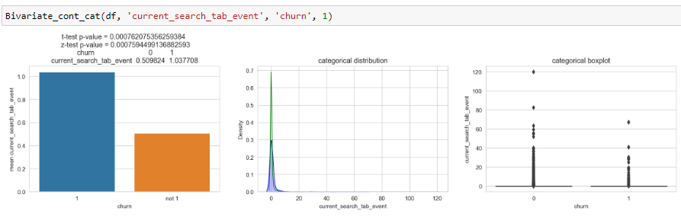

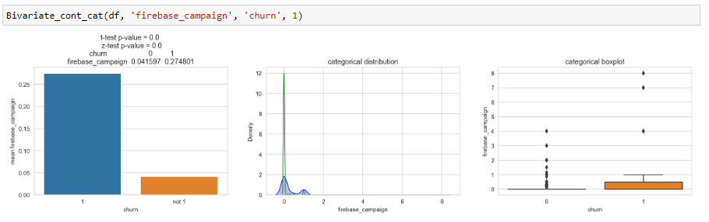

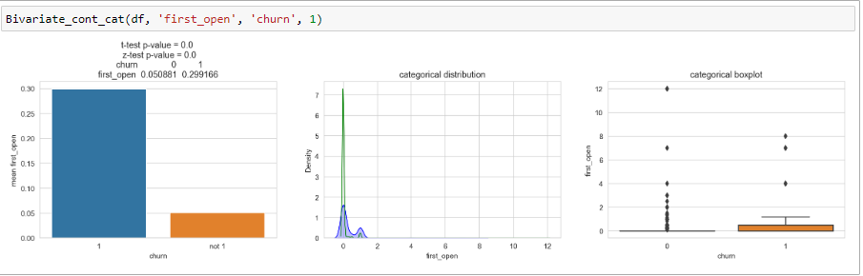

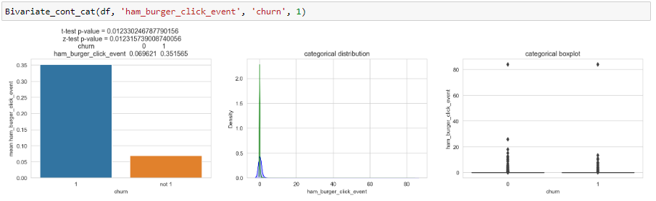

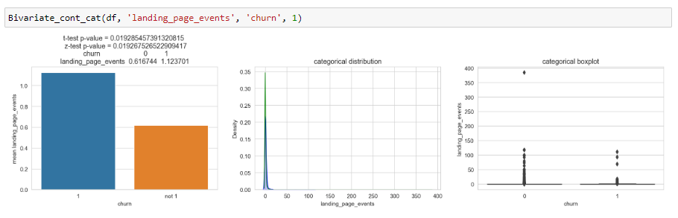

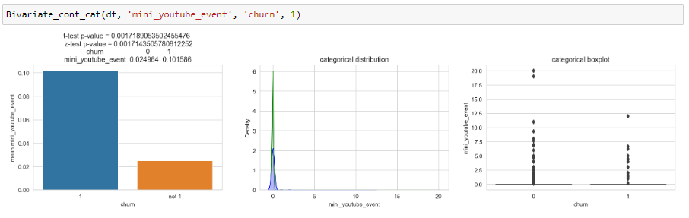

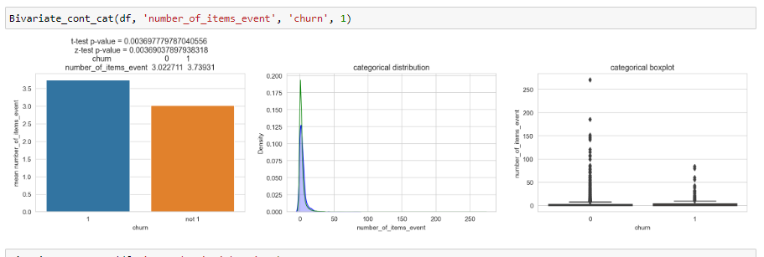

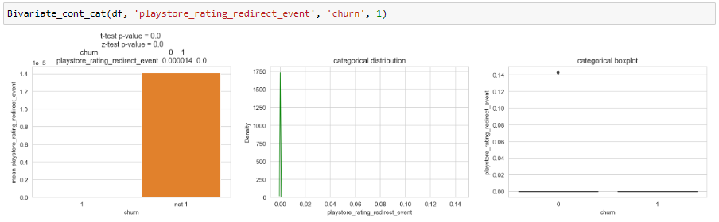

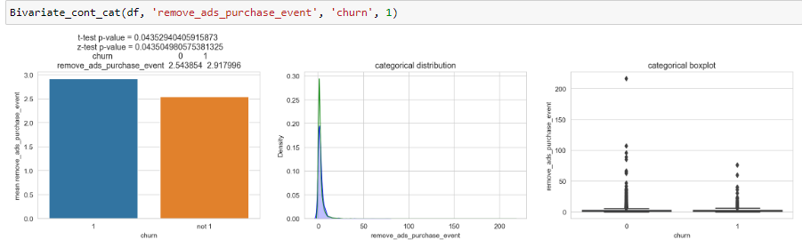

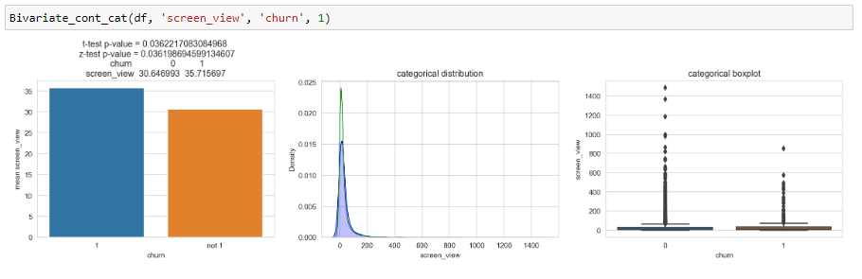

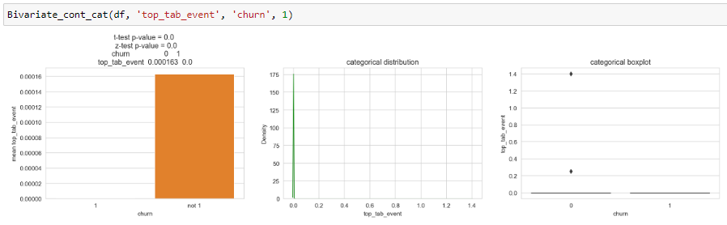

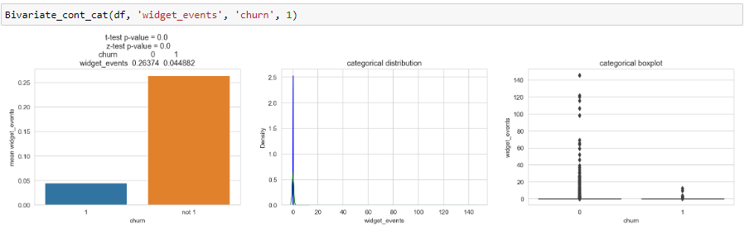

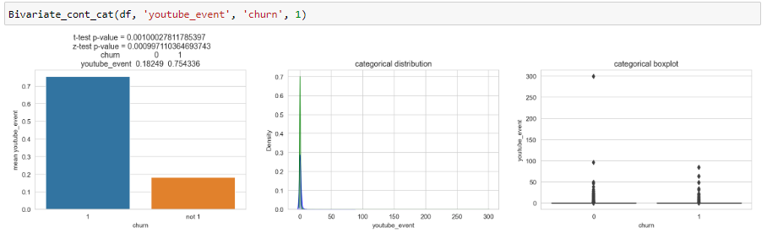

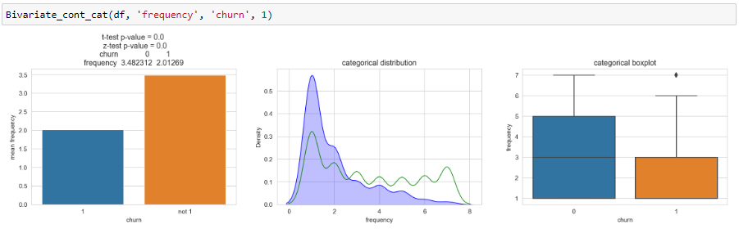

1. **Spearman Correlation Plot Between Important Features**

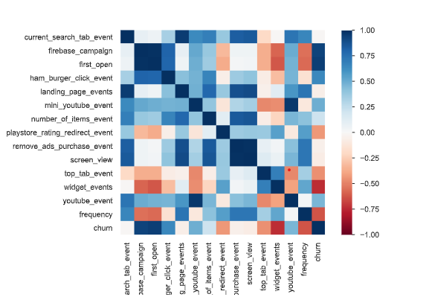

1. **Correlation Value of ‘Churn’ Feature with Other 14 Important Features**

